CS7637: Project 1: Martingale Betting Analysis

Omkar Kiran Vaidya  
ovaidya3@gatech.edu

# Report Questions

This section will answer the assignment questions.

## Question 1:

In Experiment 1, based on the experiment results calculate and provide the estimated probability of winning $80 within 1000 sequential bets. Thoroughly explain your reasoning for the answer using the experiment output. Your explanation should NOT be based on estimates from visually inspecting your plots, but from analyzing any output from your simulation.

ANS: Based on the output of the experiment, 100% of the 1000 episodes resulted in winnings of $80. In the code, the function "probability_calc" gives the percentage of episodes that result in winnings of $80.

## Question 2:

Question 2: In Experiment 1, what is the estimated expected value of winnings after 1000 sequential bets? Thoroughly explain your reasoning for the answer.

ANS: Using the given formula, $E\left[X\right]=\sum_{x}{xP[X=x]}$, since 100% of the 1000 episodes resulted in winnings of $80 (i.e. the probability of winning $80 is 100%), the expected value of winnings after 1000 sequential bets is equal to $80 * 1.0 = $80.

## Question 3:

In Experiment 1, do the upper standard deviation line (mean + stdev) and lower standard deviation line (mean – stdev) reach a maximum (or minimum) value and then stabilize? Do the standard deviation lines converge with one another as the number of sequential bets increases? Thoroughly explain why it does or does not.

ANS: In experiment 1, it appears that there are three stages to the standard deviation lines. In the first stage, there appears to be significant variation in the upper and lower standard deviation lines due to strings of consequent losses. As the number of spins increases, there appears to be no real pattern on whether the standard deviation increases or decreases. This phenomenon can be verified by fitting a linear regression line on to the standard deviation set, and then setting different random seeds to check if the slope of the linear regression line changes due to variability. When checking for this, there doesn't seem to be any consistency in the sign or magnitude of slope of the line. Since I needed to keep the random seed constant, I did not include the relevant code in the code file, however, figures 6 & 7 give two examples of different slopes for different seeds. Another thing to keep in mind for the first stage is that the probability of an episode reaching the $80 threshold is virtually zero.

In the second stage (at around 175-200 spins), the standard deviation rapidly decreases, as the likelihood of an episode reaching the $80 threshold increases. At this stage, more and more episodes hit the $80 threshold, which drastically reduces the standard deviation.

In the last stage, the likelihood of an episode not reaching the $80 threshold is virtually zero, therefore the standard deviation is zero.

In summary, the standard deviation lines only converge rapidly to zero (or $80 in figure 2) during a particular stage (see stage 2), but before that stage, the standard deviation distribution over time appears to be random.

## Question 4:

In Experiment 2, based on the experiment results calculate and provide the estimated probability of winning $80 within 1000 sequential bets. Thoroughly explain your reasoning for the answer using the experiment output. Your explanation should NOT be based on estimates from visually inspecting your plots, but from analyzing any output from your simulation.

ANS: Based on the output of the experiment, 659 of the 1000 episodes (0.659) resulted in winnings of $80, when using the code for question 2.

.

## Question 5:

## In Experiment 2, what is the estimated expected value of winnings after 1000 sequential bets? Thoroughly explain your reasoning for the answer.

ANS: Using the expected value formula, .659(80) + .341(-256) = $-34.576. Another method would be to extract the 1000th winnings for all episodes, and finding the mean value.

## Question 6:

In Experiment 2, do the upper standard deviation line (mean + stdev) and lower standard deviation line (mean – stdev) reach a maximum (or minimum) value and then stabilize? Do the standard deviation lines converge with one another as the number of sequential bets increases? Thoroughly explain why it does or does not.

ANS: Looking at figure 4, it appears that both upper and lower bounds converge to two separate values. This is because all episodes settle on either $80 or -$256. The mean would be equal to expected value, and the upper and lower bounds would be the expected value plus or minus the standard deviation ($-34.576 ±158.99$). One difference when having a limited bankroll is that episodes can finish on -$256 much earlier since success is not guaranteed as with an infinite bankroll. As more episodes get stuck on -256, the standard deviation steadily increases until it reaches its final point.

## Question 7:

What are some of the benefits of using expected values when conducting experiments instead of simply using the result of one specific random episode?

ANS: The result of a single episode only gives you the result of one repetition, and cannot be the basis for a long term betting strategy. For example, a single martingale episode may show winnings of $80 with a bankroll of $256, but if the strategy is employed every week, on average you will lose money (roughly $34.58 one average each week). The expected value gives an idea of what can be achieved consistently. In fact, even the expected value can sometimes be misleading since it does not consider risk. Even with a positive expected value, the martingale strategy is highly risky. In experiment 1, figure 1, some of the episodes take deep nose dives, in which case the gambler would lose a significant amount of money. The more spins he takes, the greater the likelihood of encountering a long series of loses, which increases exponentially with a base power of 2.

# Figures

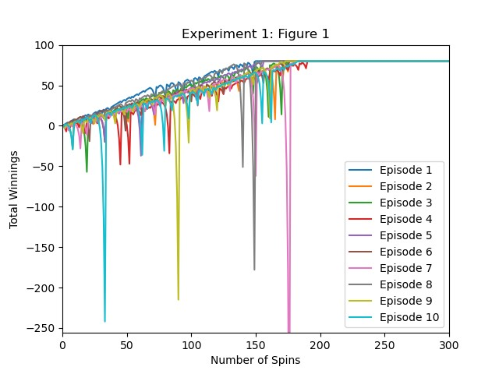

1. Experiment 1: Winnings of ten episodes over spins.

1. Experiment 1: Mean Winnings at each spin round

1. Experiment 1: Median Winnings at each spin round

1. Experiment 2: Mean Winnings at each spin round

1. Experiment 2: Median Winnings at each spin round

1. Question 3: Standard Deviation Regression

1. Question 3: Standard Deviation Regression